Summary of 2019 Western Hemlock Looper Monitoring Surveys in the Columbia, Arrow and Kootenay Lakes Forest Districts

Three-tree beatings were undertaken in early July in 25 permanent sample plots (PSP) established to monitor western hemlock looper populations (Figure 1). All defoliators, both primary and secondary, were recorded. Six-trap clusters were also deployed at the time of tree-beatings in 11 of the 25 PSP’s.
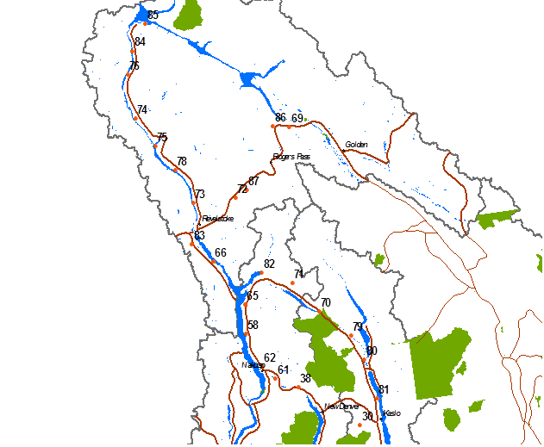
Figure 1. Location of western hemlock looper monitoring sites in the Columbia, Arrow and Kootenay Lake Forest Districts.

Tree Beatings
For the second consecutive year defoliator activity increased with larva found in 24 of 25 PSP’s (Table 1); 567 larva total compared to 188 in 2018. Western hemlock looper (Figure 2) was found in 92% of the sites up from 52% in 2018, with average counts increasing threefold from 32 to 100. Bigmouth Creek had the highest count at 9 larvae, followed by Gerrard and Box Lake with 8 larvae each. Sawfly numbers also increased found in 56% of the plots, with the highest level recorded at Keen Creek between New Denver and Kaslo. Box Lake had the highest defoliator activity with 6 different species leading to trace to light defoliation (Figure 2) with the dominant defoliator being saddleback looper (Figure 2). In fact there were so much feeding you could hear frass dropping form the trees. In terms of species diversity 10 species total were recorded, down slightly from 10 in 2018.
Table 1. Summary of primary and secondary defoliators found at 25 monitoring sites in 2019.
Plot | TSA | Location | Western Hemlock Looper | Black-headed budworm | Sawflies | Green-striped forest looper | Western False Hemlock Looper | Gray Spruce Looper | Saddleback Looper | Filament Bearer | DEFOLIATON ESTIMATE
30 | DLK | Keen Crk | 6 |  | 60 | 2 |  |  | 4 | 3 | Nil
38 | DAR | Hills | 6 |  |  | 4 | 6 |  | 4 |  | Nil
58 | DAR | Halfway River | 4 |  |  |  | 1 |  |  |  | Nil
61 | DAR | Box Lake | 8 |  | 77 | 3 | 2 |  | 40 | 25 | T-L
62 | DAR | Kuskanax Crk | 3 |  |  | 5 |  |  |  |  | Nil
65 | DAR | Shelter Bay Ferry | 2 |  |  |  |  |  |  |  | Nil
66 | DGO | Sutherland Falls | 2 |  |  |  |  |  |  |  | Nil
69 | DGO | Quartz Crk | 1 |  | 6 | 1 |  |  |  |  | Nil
70 | DKL | Gerrad | 8 |  | 27 |  |  |  |  | 1 | Nil
71 | DCA | Trout Lake | 5 |  |  |  |  |  |  |  | Nil
72 | DRE | Tangier FSR | 6 |  | 12 |  |  |  |  | 3 | Nil
73 | DRE | Martha Crk | 4 |  | 3 |  | 1 |  |  |  | Nil
74 | DRE | Goldstream River | 2 |  | 3 |  |  |  |  |  | Nil
75 | DRE | Downie Crk | 3 |  | 10 |  |  |  |  |  | Nil
76 | DRE | Bigmouth Crk | 9 |  | 2 |  |  |  |  |  | Nil
78 | DRE | Carnes Crk | 0 |  |  |  |  |  |  |  | Nil
79 | DRE | Lardeau FSR | 7 |  |  | 3 |  |  |  |  | Nil
80 | DKL | Meadow Crk | 2 |  |  |  |  |  |  |  | Nil
81 | DKL | Schroeder Crk | 2 |  | 15 |  |  |  |  |  | Nil
82 | DAR | Beaton | 3 |  |  | 1 | 1 |  |  |  | Nil
83 | DRE | Begbie Crk | 2 |  |  | 1 |  |  | 1 | 13 | Nil
84 | DRE | Pitt Crk Rec Site | 6 |  | 35 |  |  |  |  |  | Nil
85 | DRE | Kinbasket Lk | 4 |  | 38 |  |  |  |  |  | Nil
86 | DGO | Beaver River | 0 |  | 42 |  |  |  |  |  | T
87 | DRE | Jumping Crk | 5 |  | 9 |  |  |  |  | 1 | Nil
 |  | Total | 100 | 0 | 339 | 20 | 11 | 0 | 49 | 46 | 567

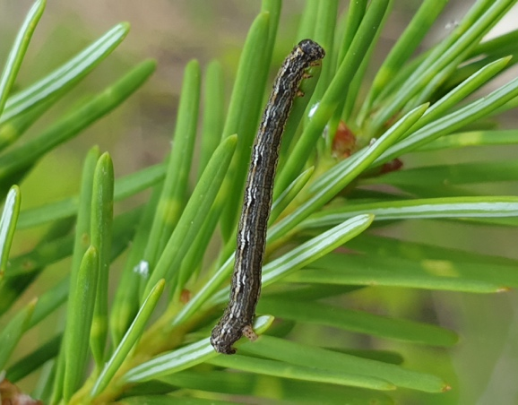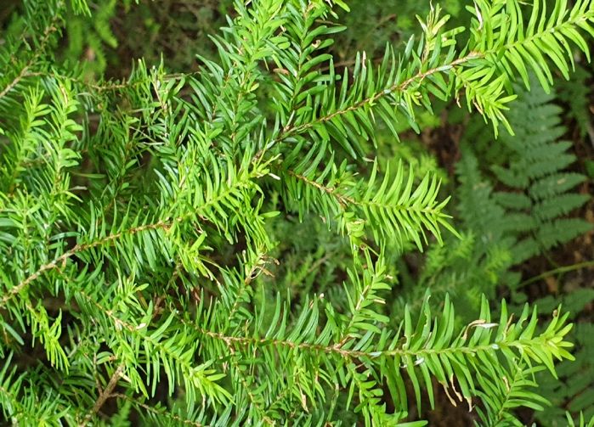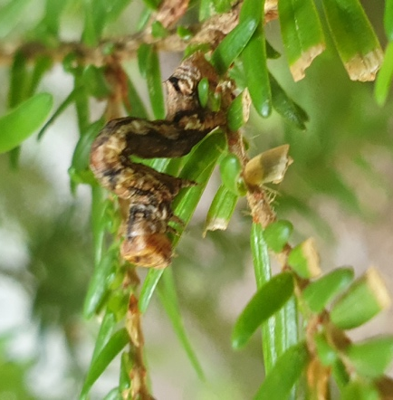
Figure 2. Box Lake: Left -Western hemlock. Middle - trace feeding damage. Right - Saddleback looper and feeding damage.

Six-Trap Clusters
For the third consecutive year increases were noted across the majority of traps, with an overall fourfold average increase from to 68 in 2018 to 269 in 2018. All trap sites increased with the exception of Tangier FSR and Martha Creek where decreases occurred. Similar to last year the highest averages were at Kinbasket Lake (518), and Begbie Creek (658). The highest overall increase was at Begbie Creek, from an average of 97 in 2018 to 657 in 2019. Less notable increases were seen at Bighmout Creek, from 55 in 2018 to 88 in 2019. Note the traps at Jumping Creek were not retrieved as the access road has turned into a gravel pit. This site will require relocation in 2020.
Figure 3. Average number of moths caught since the last outbreak (2013-2019) in traps located in areas historically defoliated by western hemlock looper in the Columbia region.
Table 2. Average six- trap cluster catches at 10 western hemlock looper adult monitoring sites in the Columbia, Arrow and Kootenay Lake Forest Districts, from 2004-2019. Traps were collected in early October.
PSP | Location | 2013 | 2014 | 2015 | 2016 | 2017 | 2018 | 2019
66 | Sutherland Falls | 40 | 21 | 2 | 1 | n/a | 72 | 235
83 | Begbie Crk | 171 | 23 | 11 | 0 | 50 | 97 | 658
72 | Tangier FSR | 110 | 23 | 19 | 1 | 19 | 98 | 56
87 | Jumping Crk | 36 | 4 | 3 | 5 | 41 | n/a | n/a
73 | Martha Crk | 105 | 31 | 3 | 3 | 23 | 86 | 33
78 | Carnes Crk | 66 | 7 | 5 | 3 | 15 | 8 | 257
75 | Downie Crk | 86 | 24 | 9 | 9 | 9 | 35 | 246
74 | Goldstream River | 137 | 23 | 2 | 3 | 42 | 55 | 257
76 | Bigmouth Crk | 38 | 2 | 2 | 1 | 26 | 55 | 88
84 | Pitt Crk Rec Site | 13 | 6 | 4 | 2 | 50 | 25 | 342
85 | Kinbasket Lk | 83 | 4 | 9 | 2 | 20 | 145 | 518
 | Average | 80 | 15 | 6 | 3 | 29 | 68 | 269

Other Noteworthy Pests
Pest | Severity | Location | Comment
Spruce beetle | Moderate to severe | Glacier National Park | Expanded from 2018
Birch leaf miner | Moderate to severe | New Denver to Kaslo
 | Moderate to severe | Revelstoke to Galena Bay ferry | Some trees refoliating
 | Light to moderate | Crazy Creek eastward to Rogers Pass
Serpentine leaf miner | Moderate to severe | Nakusp to Kaslo
Drought/Douglas-fir beetle | Varied | Three Valley Gap to Revelstoke | On Fd on south-facing dry slopes
Douglas-fir beetle | Varied | Craiglacheeie, Crazy Creek
Birch dieback | Severe | Hills, New Denver | Ongoing
Western red cedar/drought damage | Severe | West side of Revelstoke Lake | Drought symptoms; yellowing trees and top-dieback.

